Table of Contents

TurboCASH5-3-Release Candidate 8 1

Installation 1

FIXED / ADDED 1

CHINESE 1

INSTALL – Only few languages /countries 2

Looking for more Sets of Books templates 3

Download a Set of Books 3

Overwrite files confirmation 4

New Files included in folders 5

Versioning - TurboCASH5-3 5

Install 5

Uninstall 7

TurboCASH5-3 in Start and folders 7

TurboCASH5-2 Icons / TurboCASH5-3 8

# TurboCASH5-3-Release Candidate 8

## Installation

**Install file : TurboCASH5-3-RELEASE-CANDIDATE-8.exe Google Drive link =** [**https://drive.google.com/file/d/15lfe6bsVP33TN9T9Ku_6AeJETJuy6o40/view?usp=drive_link**](https://drive.google.com/file/d/15lfe6bsVP33TN9T9Ku_6AeJETJuy6o40/view?usp=drive_link)[**https://drive.google.com/file/d/1xXELvkIyMWQNk2VH28AOwq3FAKJccvrN/view?usp=drive_link**](https://drive.google.com/file/d/1xXELvkIyMWQNk2VH28AOwq3FAKJccvrN/view?usp=drive_link)

**Install Source file : TC5-3-MERGE-Install-SOURCE-RELEASE-CANDIDATE-8.zip Google Drive link =**

[**https://drive.google.com/file/d/1xXELvkIyMWQNk2VH28AOwq3FAKJccvrN/view?usp=drive_link**](https://drive.google.com/file/d/1xXELvkIyMWQNk2VH28AOwq3FAKJccvrN/view?usp=drive_link)

### FIXED / ADDED

* FIXED - Outstanding issues with document layout files and reports retested in both Firebird and MSSQL.

### CHINESE

* INSTALL CHINESE - Addes the Chinese (Simplified) to the install script. Installs ok but the Install wizard will probably show correct if installed in a Machine with the Chinese (Simplified) system's language and regional settings in the Windows or operating system. See chinese-install-ino.png - image in English Windows system's language and regional settings.

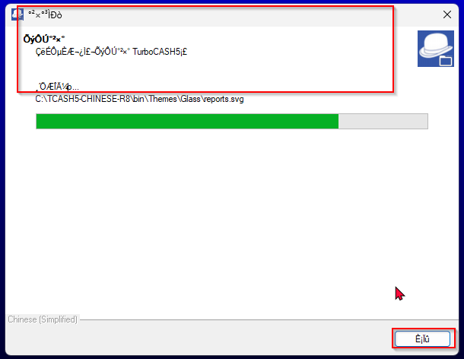

* ADDED - bin/CHINESE folder - includes your 4-CAS-GENERIC Set of Books and HANDYMAN-A tutorial.

NOTE: I have not made the HANDYMAN and HANDYMAN-B Set of books as requested yet. The reason for this - Groups descriptions not translated - and CHART OF ACCOUNTS includes un-Chinese numbering before account descriptions.

Should I remove the numbering and try to create the HANDYMAN and HANDYMAN-B? (I have pointed it out it in a previous mail)

# INSTALL – Only few languages /countries

The install script file changed – 2025-TC-5-2-Setup-LESS-REP.iss

The bin/Repository is reduced and only include 10 Sets of Books.

Commented other installs - only the following languages is installed:

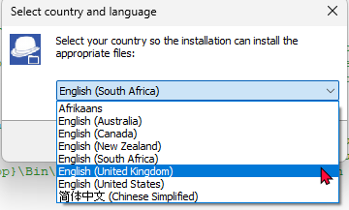

Select language and country

1. Afrikaans - Installs the following Sets of Books:

* AF-SUID-AFRIKA
* EN-SOUTHAFRICA
* 4-AF-SUID-AFRIKA-GENERIES

1. English (Australia) - EN-AUSTRALIA
2. English (Canada) – Installs the following Sets of Books:
   * EN-CANADA-CORPORATION
   * EN-CANADA-OTHER
3. English (New Zealand) - EN-NEWZEALAND
4. English (South Africa) - Installs the following Sets of Books:
   * EN-SOUTHAFRICA
   * 4-EN-SOUTH-AFRICA-GENERIC
   * AF-SUID-AFRIKA-GENERIES
   * EN-UK (Installs but needs to be removed)
5. English – (United Kingdom)
   * EN-UK
   * 4-EN-UK-GENERIC
6. English (United States) - Installs the following Sets of Books:
   * EN-USA
   * EN-US-CALIFORNIA
   * EN-US-GENERIC
7. Chinese (Simplified) ) - Installs the following Sets of Books:
   * 4-CAS-GENERIC
   * HANDYMAN-A

## Looking for more Sets of Books templates

If your language and country is not installed, you may go to the **Create Set of Books** on the **Start** ribbon or press F10.

The bin/Repository now includes only 10 Sets of Books for the install

Sets of Books linked to that language in the install and most Sets of Books that are not included in the install is removed from the bin/Repository folder.  
  
Which Chart of Accounts do you want to use?  
  
If a user is looking for something else what is not installed they may locate the Specific Set of Books for their country and language, industry from there.  
The Repository folder includes all Sets of Books available in the "Download" option "Let TurboCASH help you to create a Set of Books?" on the creation wizard F10.

## Download a Set of Books

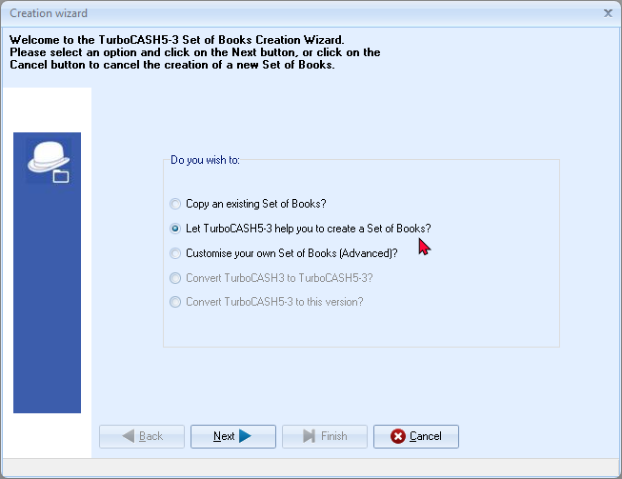

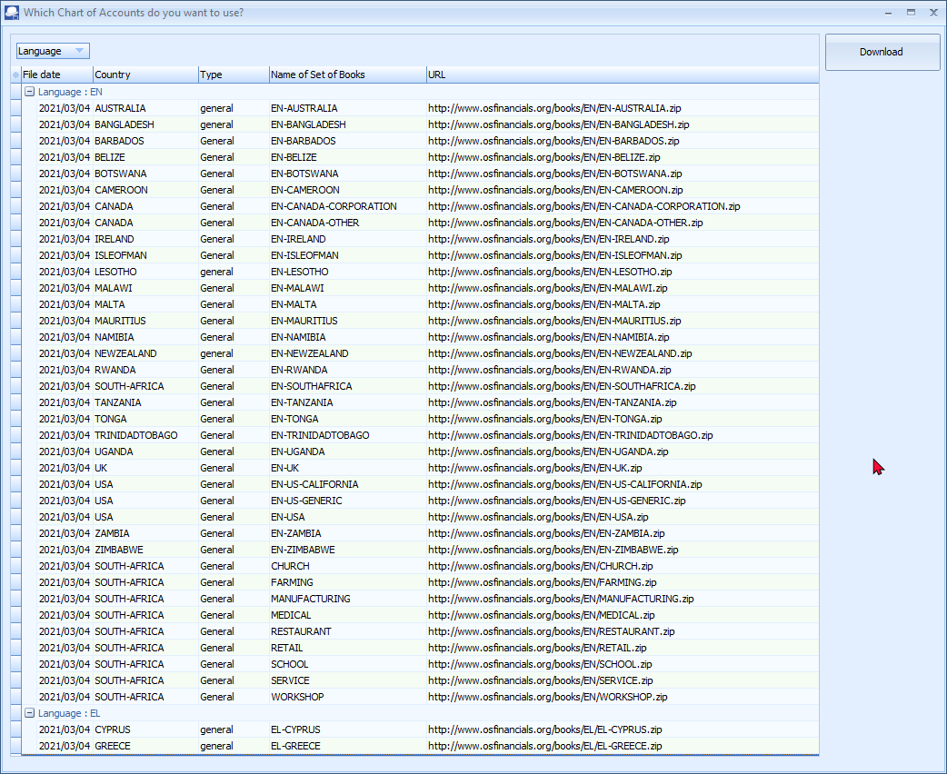

The languages and countries are clearly grouped by language iso codes.

NOTE – Downloading a Set of Books in a different language not supported by your system locale and/or regional language settings of your operating system my cause characters not displaying correctly in the osFinancials/TurboCASH interface and reports.

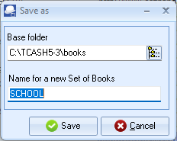

These downloadable Sets of Books are stored in the <https://www.osfinancials.org/en/productinformation/technical-information/databases> - NOTE - You may need to update your stat of the financial year in Setup -> Reporting dates.

## Overwrite files confirmation

Overwrite files confirmation needs to be rechecked when installing in a clean folder.

When installing TurboCASH5-3-Release-Candidate-8 in the an existing directory you may receive two messages:

1. **Directory exists** - Confirm to install in the existing directory or select no to choose a different directory.
2. **Set of Books exists** - Confirm to keep the existing Set of Books or choose to overwrite (replace the files in the Set of Books).

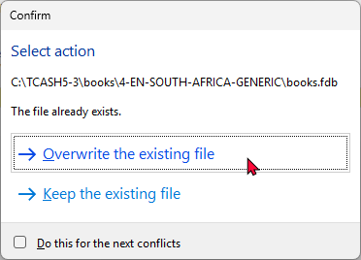

## New Files included in folders

New Files included in the following folders

bin/AI folder - turbocashaibible1-01.pdf

bin/CHINESE - Set of books is included in this folder:

4-CAS-GENERIC

HANDYMAN-A (Tutorial)

# Versioning - TurboCASH5-3

## Install



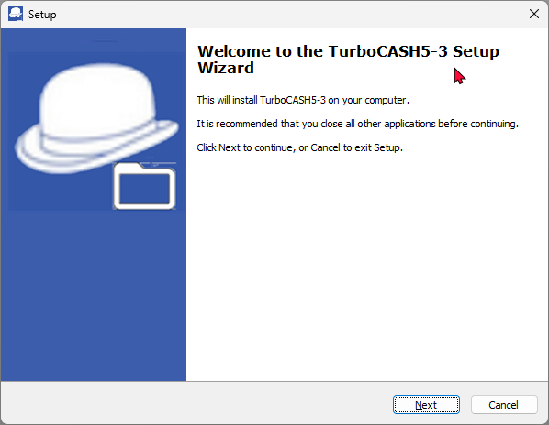

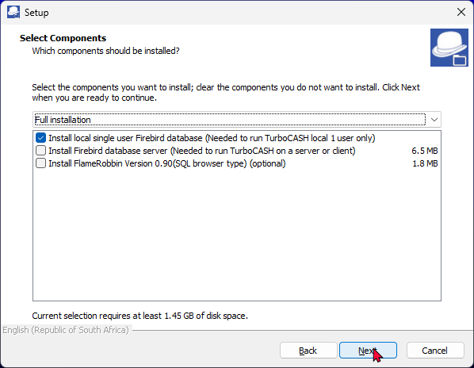

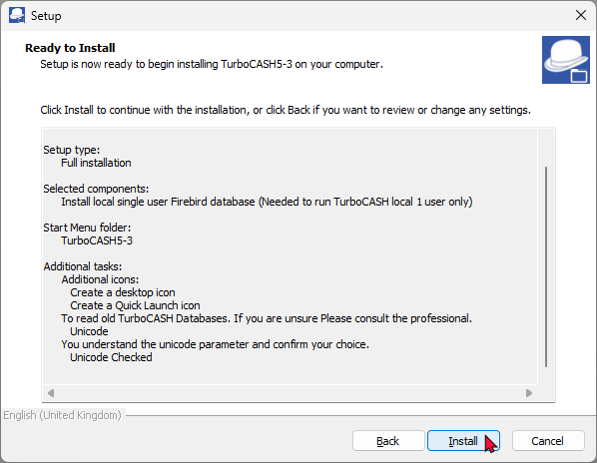

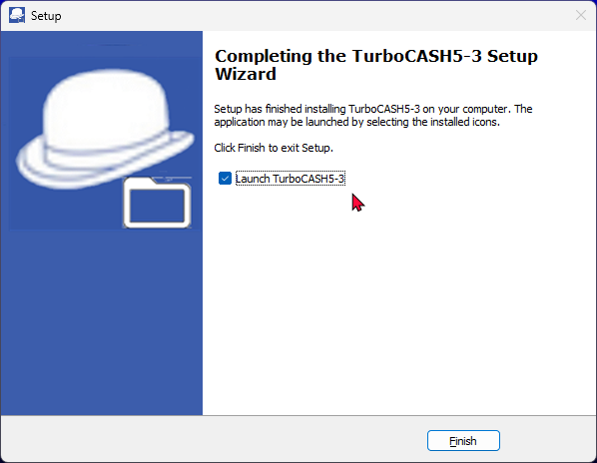

## Uninstall

TurboCASH5-3 Uninstall dialogs are clearly identifiable.

If unclear version number – happens that I uninstalled the wrong version.

## TurboCASH5-3 in Start and folders

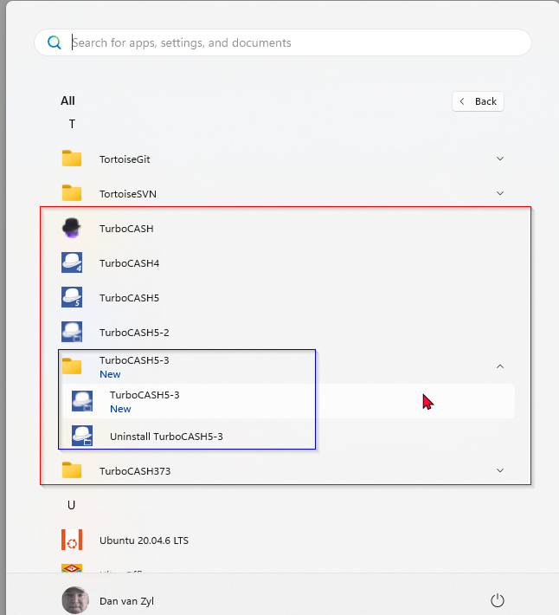

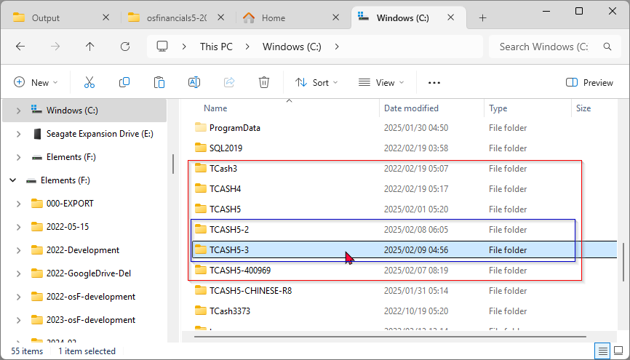

## TurboCASH5-2 Icons / TurboCASH5-3

